- During the activity:
 | Strongly disagree | Disagree | Agree | Strongly  agree
We had lots of different ideas
We agreed on a plan
We did lots of experimenting
We didn’t mind making mistakes
Each person had a job
I was listened to
I asked questions
I was the leader

- How did you feel at the start (S), middle (M) and end (E) of the task? Write S, M and E next to the emoticons that are nearest to how you felt at different times.
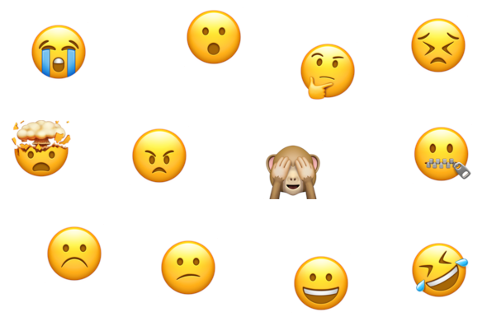
- The two best things about the way our group worked were:
i.

ii.

